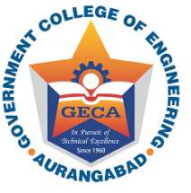 | In Pursuit of Global Competitiveness  Government College of Engineering  Station Road, Osmanpura, Aurangabad – 431 005  [An Autonomous Institute of Government of Maharashtra]  Phone : (0240) 2366101 Fax : (0240) 2332835 Web – http://www.geca.ac.in

Date : 12/08/2019

ADMISSION NOTIFICATION
Government College of Engineering, Aurangabad announces admission through ‘ON THE SPOT COUNSELING ROUND’ to the First Year Engineering undergraduate courses for seats remained vacant after CAP rounds of State CET Cell for the academic year 2019-20. This round will be conducted on 14/08/2019. However, if cutoff date is extended by competent authority before the start of ‘on the spot counseling round’, then this round will be conducted later, date of which will be announced on the institute website. For vacancies and all other details please see and remain in contact with institute website www.geca.ac.in.
Sd/- Principal

