Government College of Engineering Aurangabad

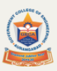

Department of Mechanical Engineering
Annual Meeting Report of READY ENGINEER Program
In association With TATA Technologies Ltd Pune
Date 06/10/2021

Dr. U. J. Kahalekar
Principal, GECA Aurangabad

Dr A M Nikalje Mrs Saili R Kulkarni
Head MED GECA Dr U V Hambire
Ready Engineer Coordinator

Department of Mechanical Engineering

Ready Engineer is Tata Technologies Corporate Social Responsibility (CSR) Initiative. Ready Engineer Program offers a training ecosystem for Professors as well as students on Industry practices and insights on Automotive Design and relevant tools along with other trainings (Soft Skills, Employability Assessments, Scholarships, and Industrial Projects etc.) to enhance the employability skills of Engineers in Tier 2 and Tier 3 cities.

Background
Back in year 2010, while the company was reflecting on its long terms growth plans in terms of business sustainability, to outperform its market competitors and achieve greater profits, one factor came out that critically determines such growth was constant acquisition of talented and skilled engineers. The company recruited Graduate Engineering Trainees (GETs) reflected the lack of “readiness” to be able to start working on customer projects. Factors affecting the students readiness were
Poor upgradation of Engineering syllabus w.r.t. technological developments and lack of application- oriented content.
Lack of experienced and qualified Professors in the colleges
Lack of innovation & research attitude among the engineering students
Lack of English communicative skills, analytical and quantitative skills
Limited hands-on training on the problems encountered in the industry
Lack of skill-based education

The purpose of the Ready Engineer programme is to bridge the engineering industry talent gap by educating and mentoring aspiring young engineers. The aim is to be a catalyst in reducing the academia-industry gap and ensure that the future engineers are ready for the industry.
Annual Meeting held on 6/10/2021, Wednesday at 2.00 PM at ICT Class room Department of Mechanical Engineering, Government College of Engineering Aurangabad.
Agenda of Meeting
- Updating of status of RE SPOC
- Confirmation of student registration Status
- Discussion on New Ready Engineer Portal
- Information about project “Pratyana-2021-22”

Annual Meeting Start at 2 PM at Mechanical Engineering Department following dignitaries were present
- Hon. Dr U J Kahalekar, Principal GECA
- Mr Ajit Habbu, Manager – Corporate Sustainability & CSR
- Siddharth Yawalkar -Associate – Corporate Sustainability & CSR
- Dr A M Nikalje – HEAD Mechancial Engineering Dept. GECA
- Faculty Members from various Engineering Institute from Aurangabad region
Principal Dr U J Kahalekar initiated meeting by Welcoming company Delegates Mr Ajit Habbu and Mr. Siddharth Yawalkar.
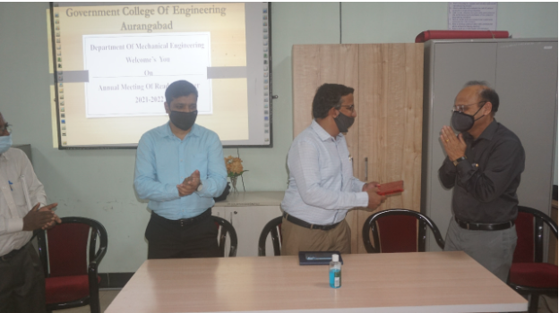
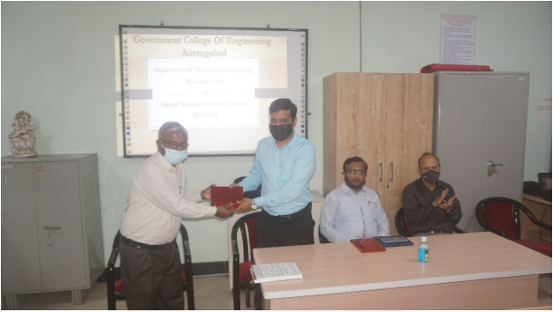
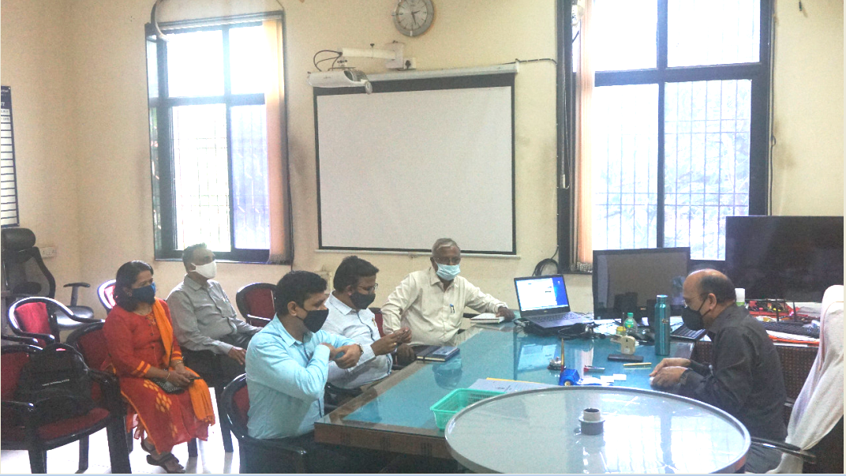

Dr A M Nikalje Head MED Briefly introduce READY Engineer Program to all faculty Members. He appreciates the efforts taken by TATA Technologies to bridge the gap between Industry and Institute.
Dr U J Kahalaker, Principal GECA focuses on enhancing the involvement of Principal of various Engineering Institutes so that more students will be benefited. He also focuses on enhance the skill of solving real life problem in students. He also appreciates efforts taken by SPOC faculties.
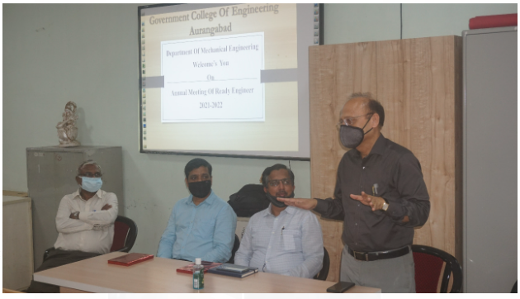
Mr Ajit Habbu and Mr Siddharth a took brief review of registration of students of 5th semester for academic year 2021-22 and emphasis on make awareness of this program among all students.
Mr Siddharth briefly gives demo on New portal of Ready Engineer. He inform about new Project about Pratyana 2021-22 for 7th and 8th semester students. He also solve various queries raised by SPOC of various Institutes
He requests all SPOC run the Program in given schedule time and encourage all students to regularly use the READY Engineer Portal and watch the Domain as well as soft skill videos and make this program successful.
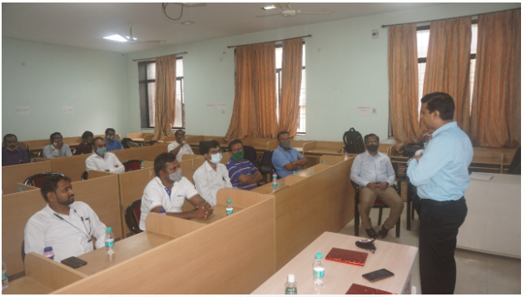
By delivering Vote of Thanks by Mrs Saili Kulkarni MED GECA the meeting was Conclude.






